1. On opening the website, the user should see the home page. The home page consists of a navigation bar at the top, quick links on the right and all the courses in the database in the main body:

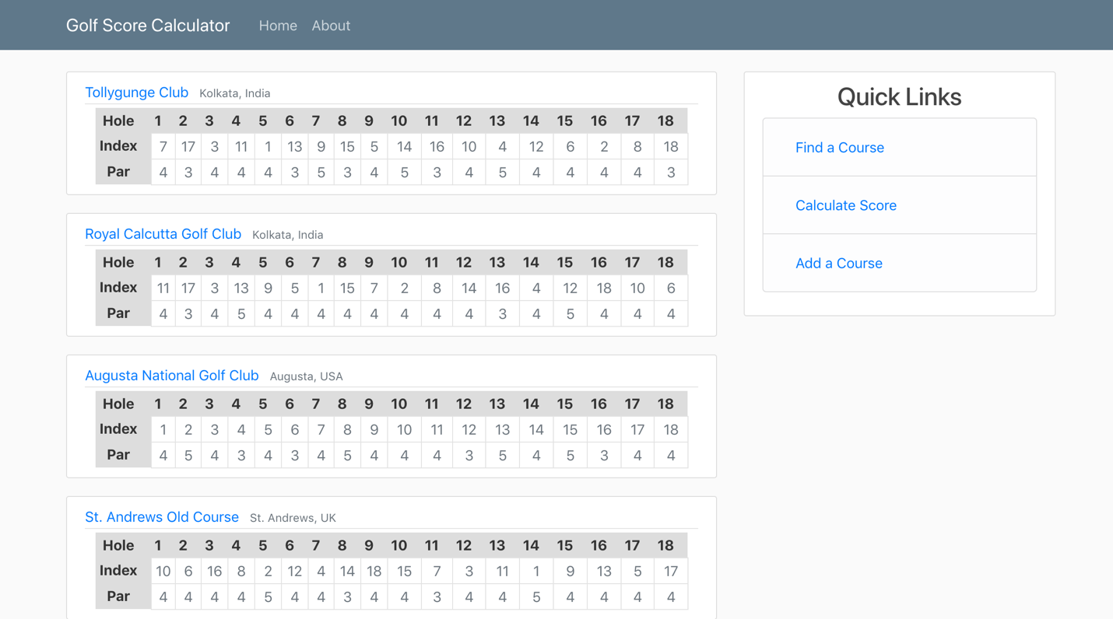

1. The about page is a brief writeup about the website, what is aims to achieve and the current functionality available. There is also a link included for more information about the scoring algorithms.

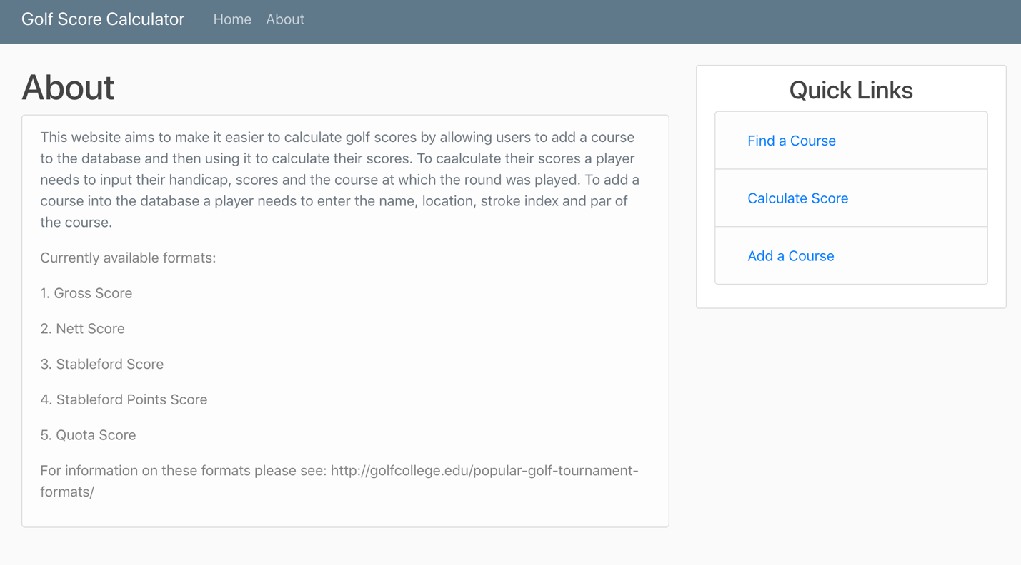

1. The Find a course link is a search function that helps users find a course that is already in the database. The search can be conducted by name, city or country attributes:

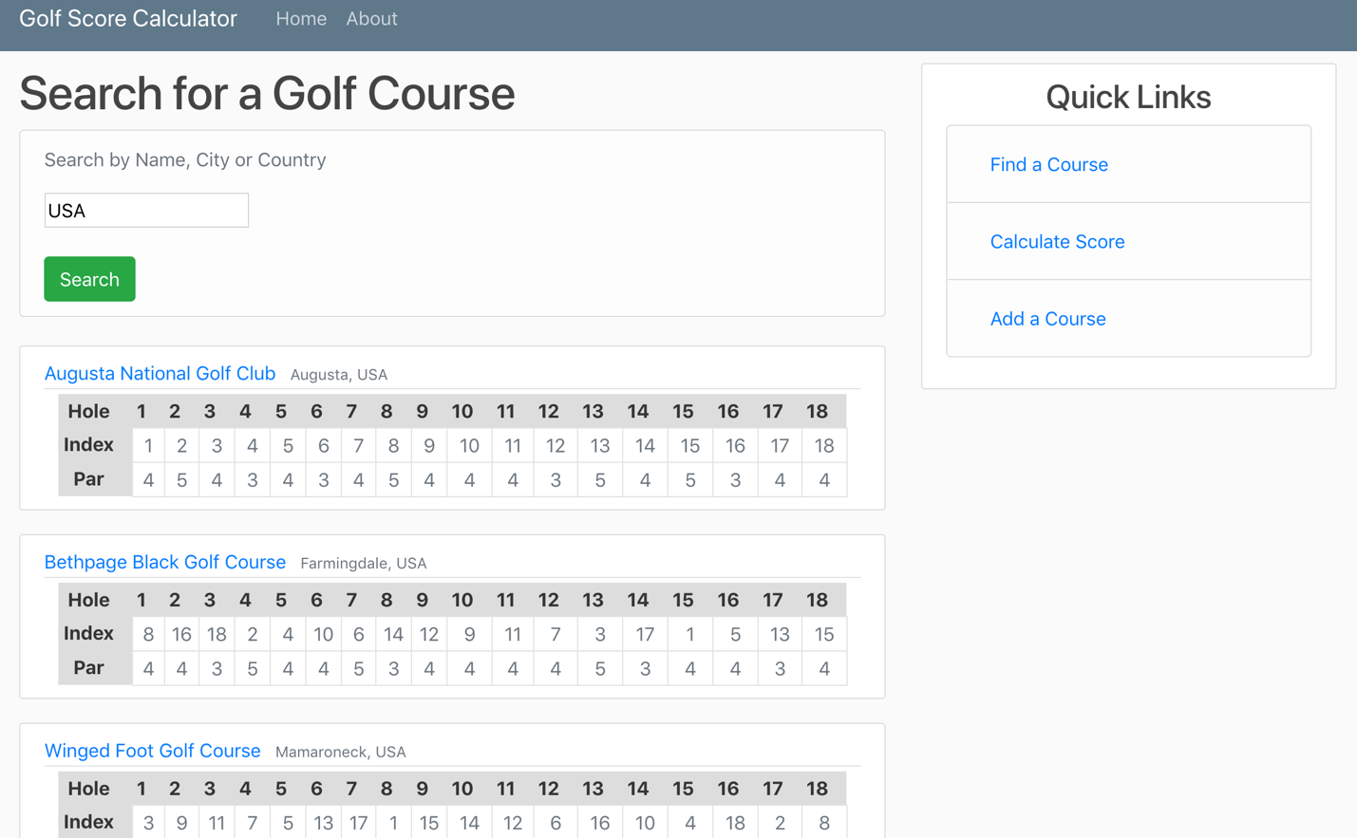

1. The calculate score page is the page through which the user enters their information and the golf scores are calculated. Current functionality includes: gross score, net score, stableford score, stableford points score and quota score:

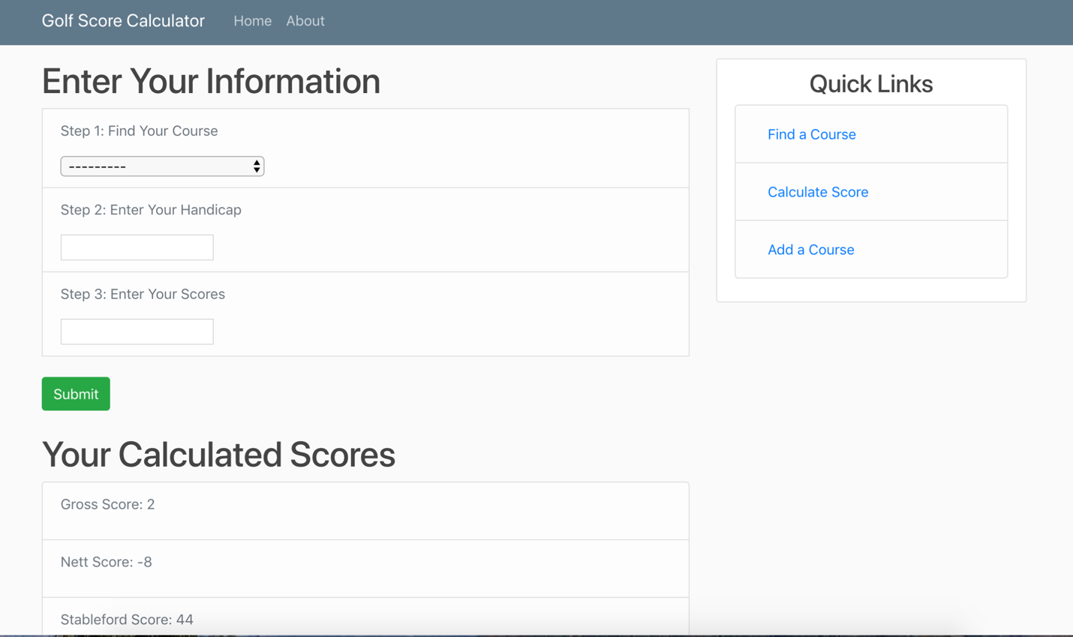

1. The Add a Course link is to add a course to the database. To add a course to the database a user needs the course name, location, par and stroke index:

